<https://www.microcontroller-project.com/automatic-door-lock-with-8051.html>

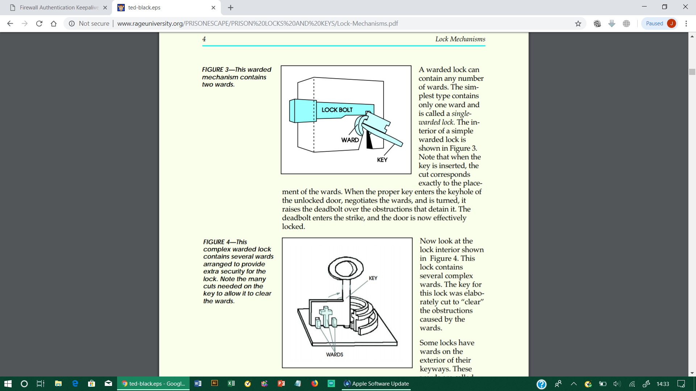

https://www.ijrter.com/published_special_issues/31-03-2017/electronic-lock-using-otp-and-alert-system.pdf